EXP 10 : PERFORMANCE EVALUATION OF DIGITAL COMMUNICATION SYSTEMS USING EYE DIAGRAMS ANALYSIS UNDER ADDITIVE WHITE GAUSSIAN NOISE (AWGN) USING MATLAB

SOFTWARE USED : MATLAB SOFTWARE

CODE :
clc; clear; close all

N=1000; sps=20; SNR=10;
bits=randi([0 1],1,N);
x=2*bits-1; % BPSK
tx=rectpulse(x,sps);
rx=awgn(tx,SNR,'measured'); % AWGN channel

subplot(2,1,1)
plot(tx(1:400),'b'),grid on
title('Transmitted BPSK Signal')

subplot(2,1,2)
eyediagram(rx,2*sps)
title('Eye Diagram under AWGN')

MODEL GRAPH :
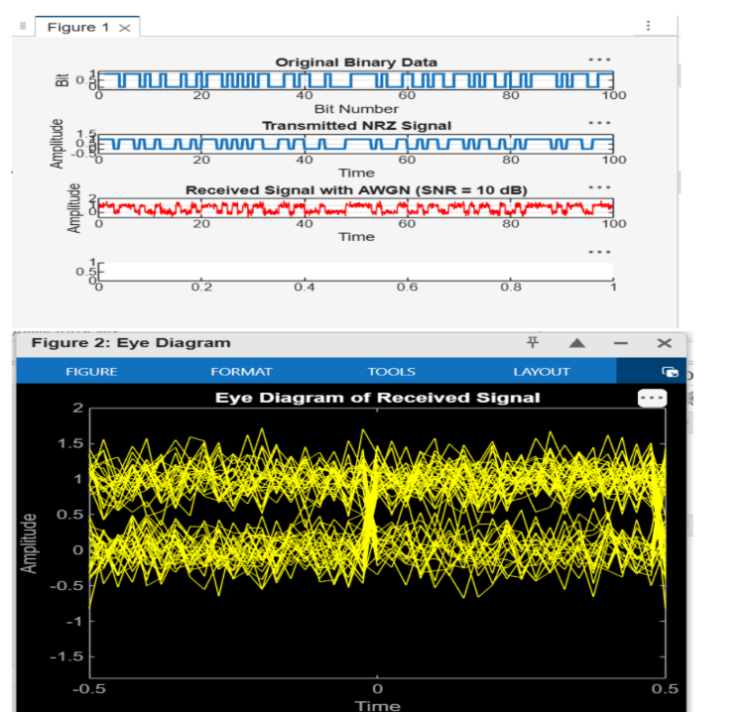
RESULT :
